Newsletter
25th September 2021

Dear Parents and Carers,
Here we are again, at the end of another wonderful week at Durham Lane Primary School. The children have had another great week in school and I have had the pleasure of spending time with all of them; I have to say they are a true credit to you. What well-mannered and polite children you have!
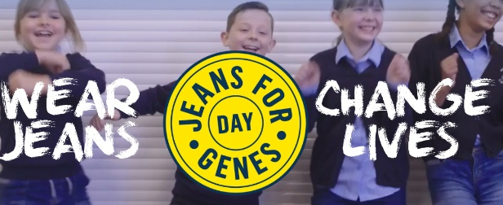

Jeans for Genes
A HUGE thank you to all our families for helping us raise £331.50 for Jeans for Genes today! Your generosity will be gratefully received by this important charity. A special mention to Lois who helped to organise this whole day!
Bikes/Scooters
I am more than happy for children to cycle to and from home. However, could I please request that all children wear a helmet and that children walk with their bikes until they are safe to cycle outside of the school premises.

Harvest Festival
A reminder that on Monday 27th September, we will be celebrating harvest. We kindly ask that (if you are able to) you send any donations of food listed below into school before Monday 27th September. All of this will be donated to our local food bank to help those in need in the local area. Each year we are blown away by your generosity and any donations sent this year would be gratefully received once again.
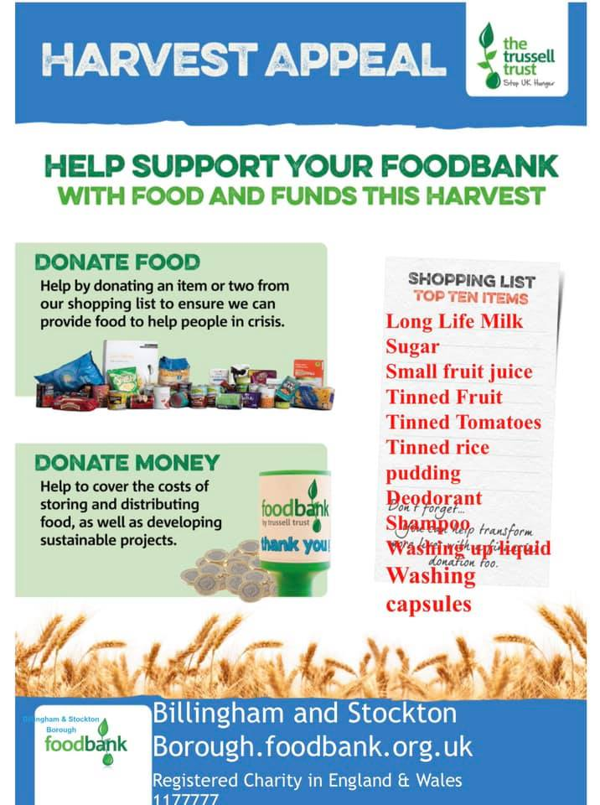

Packed Lunches
If children are bringing a packed lunch to school we
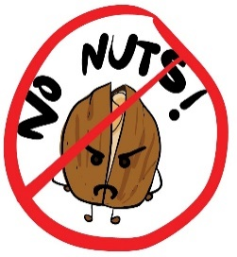
have several children in school who have severe nut allergies and request that parents do not include nuts or any nut-based products in packed lunches. Children must also bring their own drink (not fizzy) and a spoon for yoghurt or jelly. Staff based in the dining hall will monitor children on packed lunches and will encourage them to eat all items provided – please only add to a lunchbox the food you expect your child to eat.
Covid-19 and Home Learning
Could I please remind parents, if your child displays any of the following symptoms, they are to have a PCR test.
The main symptoms of coronavirus (COVID-19) are:

*a high temperature – this means you feel hot to touch on your chest or back (you do not need to measure your temperature)
*a new, continuous cough – this means coughing a lot for more than an hour, or 3 or more coughing episodes in 24 hours (if you usually have a cough, it may be worse than usual)
*a loss or change to your sense of smell or taste – this means you've noticed you cannot smell or taste anything, or things smell or taste different to normal

If you need to book a PCR test, please follow the link.
www.stockton.gov.uk/coronavirus/testing

If your child is to test positive for Covid-19 and are well enough to work from home, all learning will be put onto our school home learning platform – Seesaw.

Covid-19 testing
If your child is waiting for a Covid-19 test result, could you please email me the result, even if it is over the weekend. My email address is helen.gregory@sbcschools.org.uk

Tag Rugby
Year 4 had a brilliant morning at Conyers School, taking part in the Tag Rugby Skills Festival. They had lots of fun playing games and learning new skills with the fantastic sports leaders and they represented the school excellently, with super listening skills and positive attitudes throughout the morning!
Well done, Year 4!
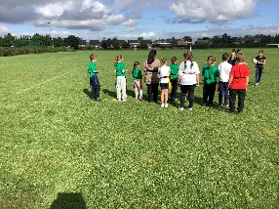

After School Clubs
It has been really nice to see the children participate in enrichment and after school clubs over the last few weeks. The LEGO Robotics club is becoming a real hit!!

‘The children have had great fun at LEGO Robotics club tonight! They programmed an earthquake simulator and tested their own structures on there to see if they could withstand the quake!’

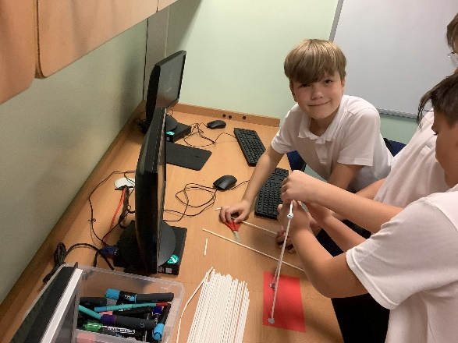

Durham Lane Clubs
Before School Club – Nursery-Year 6
8.00am- 8.45am- £4.50 (Breakfast an additional 50p)
Arrival Main School Entrance.
After School Club – Nursery- Year 6
3.15/3.20pm - 4.30pm £5.00
3.15-3.20pm - 5.50pm £10.00 (Includes a Snack Tea at 4.30pm)
Collection- Nursery Conservatory.

Activity After School Clubs £5.00
Monday – Cookery (Reception - Year 2) Starts 27th September-Collection Nursery Conservatory

Tuesday – Lego Robotics led by Miss Drew (Year 4 - Year 6)-Collection Nursery Conservatory

Tuesday – Active Kicks Football
(Year1 - Year 3)Collection Main School Entrance

Wednesday – DanceFuzion (Year 1 - Year 6) Collection Main School Entrance

Wednesday – Art Club led by Mrs Khan (Rec- Year 6) Starts 15th September -Collection Nursery Conservatory

Thursday – Multisports led by Mr Sheahan (Year 3-6) - Collection Main School Entrance

Thursday – Sewing Club (Year 2- Year 6) Starts 30th September-
Collection Nursery Conservatory

Friday – Durham Lane Newspaper and reporting club (Year 3 – Year 6) Starts 1st October-Collection Nursery Conservatory
These clubs finish at 4.30pm and are available with after school club 4.30 – 5.50pm - £5.00 (snack provided).
If your child does not want to join in with the above activities or the activities are full, you can still book our after school club.

If you wish to book your child into any of our clubs, please book via Schoolcomms/School Gateway App.
Sewing Club and Newspaper Club will be available to book on Schoolcomms/School gateway by the end of this week.

If financial implications are preventing you accessing any of the clubs, please phone our school office to arrange a discussion with Mrs Gregory.

Lunchtime Games Club- Tuesdays for Years 3, 4, 5 & 6 starts 14th September-Please book your free place on Schoolcomms.

Thank you
Any questions or queries you may have, please don’t hesitate to speak to me on the playground, email me on the address below or call the school office for an appointment.
Kind regards,
Mrs H Gregory

helen.gregory@sbcschools.org.uk

