Newsletter 30th April 2024
Dear Parents and Carers,
I can’t quite believe how quickly this year is going! I would like to thank the staff for organising so many lovely activities, visits and enrichment activities for the children this term and next.

Key dates
- 6th May – Bank Holiday
- 13th – 16th May- Y6 SATs week
- 20th May – Y5 class assembly
- 22nd May – Y4 class assembly
- 24th May - Break up for half term
- 3rd June - PD day (children to return to school on 4th June)
- 4th June (for 2 weeks)- Y5 swimming
- 7th June- non-uniform day for summer fayre
- 15th June - Summer Fayre 1pm- 4.30pm
- 17th June – Healthy Sports week
- 26th – 28th June - Year 6 visit to Carlton
- 1st July - Yr1- Yr6 Sports day 1.30pm - 3.15pm (reserve day, if the weather is poor, 15th July 1.30pm- 3.15pm)
- 2nd July - Early Years’ sports day 9.10am (reserve day, if weather is poor, 16th July 9.10am)
- 3rd July – class swap meet your new teacher morning
- 3rd and 4th July – Y6 Egglescliffe Comprehensive transition days
- 8th – 12th July- Olympics week
- 12th July – Big family camp out
- 19th July – 2pm Y6 leavers’ assembly
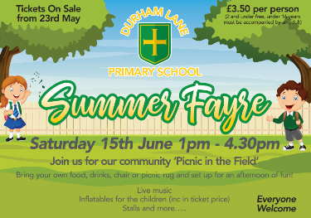

Summer Fayre
Tickets for our Summer Fayre go on sale on 23rd May via SchoolComms. The summer fayre will be a lovely chance for us all to spend time together and raise some money for our new outdoor classroom project.
We will have a large selection of stalls, inflatables, live music from Tom Powell, dancing from Y3/Y4 (Dance Fuzion) plus lots more. All you need to bring is your camping chair, picnic and drinks!
On 7th June, we are having a ‘non-uniform’ day and, in return, could we please ask for some donations for either a child’s/adult’s tombola or a cake donation for our cake stall.
Note: Tombola items to be in school on Friday 7th June, cake donations in on Friday 14th June.

We are very excited about this event and we are really hoping you can all make it. Also, this year, we are opening the event up to local residents and past/future pupils and families. However, please note this event is not suitable for pets and all children under the age of 16 will need to be accompanied by an adult. If you do have anytime to support us with this event either prior or during the day, please let Caroline Ennion or Leanne Bain know in the school office as we would be most grateful for your help.
More details to follow.
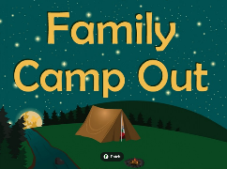
Big Family Camp out

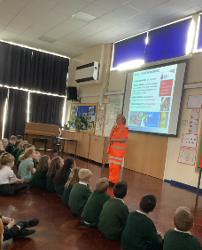
As you are aware, I do like to ask the children what they would like to do in the future. As some of you are aware, we had a very successful first ever ‘big camp out’ last year and the children have requested that we do it again on the school field this Summer. The date will be Friday 12th July. ‘Rewilding’ (an outdoor activities company) will be offering a range of activities for the evening such as archery and axe throwing. More details will follow over the coming weeks.
Network Rail
Thank you to Chloe from Network Rail who came to talk to us all about railway safety. She presented 3 separate assemblies for EYFS, KS1 and KS2. This was very informative and gave the children lots of tips to stay safe at level crossings, train lines and stations

Year 6
We would like to say a great big well done to all of the children in Year 6 for all the effort and hard-work that they are putting in to prepare them for their SATs. The children are focusing hard and can begin to look forward to their residential visit to Carlton.
Thank you

Kind regards,
H Gregory

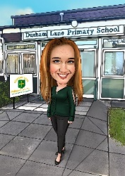
helen.gregory@durhamlane.org.uk

