

**Newsletter 16th September 2024**

**Dear Parents and Carers,**

Here we are again at the end of a wonderful first few weeks at Durham Lane Primary School.The children have had a great few weeks in school and I have had the pleasure of spending time with all of them; I have to say they are a true credit to you. What well-mannered and polite children you have!

**Bikes/Scooters**

I am more than happy for children to cycle/scoot to and from home. However, could I please request that all children wear a **helmet** and that children walk with their bikes/scooters until they are safe to cycle **outside of the school premises**. Also, due to safety concerns surrounding batteries, electronic scooters are **not** permitted on school grounds.

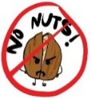

**Packed Lunches**

If children are bringing a packed lunch to school, we have several children in school who have severe nut allergies and request that parents do not include nuts or any nut-based products in packed lunches. Children must also bring their own drink (not fizzy) and a spoon for yoghurt or jelly. Staff based in the dining hall will monitor children on packed lunches and will encourage them to eat all items provided – please only add to a lunchbox the food you expect your child to eat.

**Harvest Festival**

On 2nd October, we will be celebrating harvest. We kindly ask that (if you are able to) you send any donations of food listed below into school between Friday 27th September to Tuesday 1st October (please do not send items to the office). All of this will be donated to our local food bank to help those in need in the local area. Each year we are blown away by your generosity and, any donations sent this year, will be gratefully received once again.

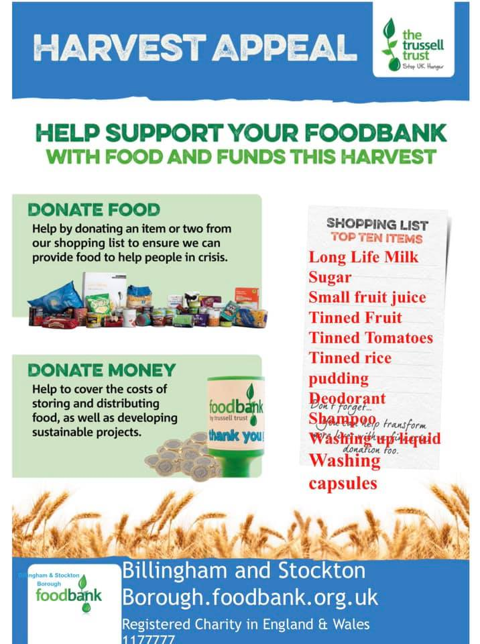

**Key dates**

* Week beginning 16th September – Y6 Bikeability
* 25th September – Cross country finals (more details to follow)
* 1st October – Y6/Y6 rugby cluster competition (more details to follow)
* 2nd October – Y6 visit the local food bank
* 9th October- tempest individual photographs
* 14th and 21st October – Parent Consultation Evening (please note there will be no Nursery consultation evening on the 14th October)
* 18th October Monster and Mayhem Disco 4.15pm – 5.15pm for Rec, Y1 and Yr2
* Monster and Mayhem Disco 5.30pm – 6.30pm Y3, Y4, Y5 and Y6 (more details to follow)
* Break up for October half term on Friday 25th October – return on Monday 4th November
* 4th November – 15th November Swimming every afternoon for Y4 (more details to follow)

**Reading**

At Durham Lane Primary, we strongly believe in the importance to our children of reading, from the minute they enter our Nursery until they leave us in Y6. In order to promote the love of reading as well as helping our children to learn and practise the skills needed to be fluent and keen readers, we have several events/initiatives planned for this coming year, as follows:

* Staff have set up and refreshed, stimulating book corners in each classroom;
* Our library will continue to welcome children from Nursery-Y6 who will be able to borrow fiction and non-fiction books;
* Our Y5/6 and Y3/4 ‘Book Buddies’ book club will begin on lunchtimes;
* Bookmarks have been distributed to Y1-Y6 parents, explaining how to support children with their reading;
* Stockton’s School librarian has visited and given out certificates, badges and goodie bags to all our wonderful children who took part in The Summer reading Challenge;
* The outside reading shed is now in operation at break and lunch times;
* Stockton Children’s book of the year will soon be relaunched for the Y6 children
* A book fair will take place in March;
* World Book Day will take place on Thursday March 6th, but we will celebrate this on Friday March 7th

**Year 6 – roles and responsibilities**

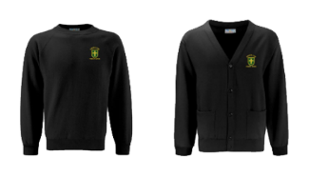It has been lovely to welcome our new Y6 pupils back to school in their smart black uniforms. As the oldest children in school, they will be given a range of responsibilities, including being librarians, being Team Captains/Vice Captains and helping the younger children at lunchtimes; we are sure they will carry out these responsibilities to the best of their ability and will be amazing role-models for our younger pupils.

**Earrings**

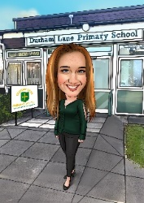Children are able to wear earrings during the school day. However, they are not permitted to wear earrings during PE lessons. Children must either be able to remove themselves or not wear them on the day of their PE lesson. Unfortunately, due to health and safety reasons we are not permitted to remove them or put tape on them. We thank you for your understanding**.**

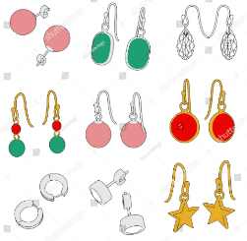

**After school activity clubs until October Half Term Holiday**

**Monday:**

* Multi sports with Mr Roberts 3.30pm – 4.25pm (Y1 and Y2)
* Multi sports with Mr Roberts 4.30pm – 5.25pm (Y3, Y4, Y5 and Y6)

**Tuesday**:

* Relax Kids Y1-Y6 with Mrs Thomson

**Wednesday**

* Dance Y1-Y6 with Mrs Barnes

**Thursday**

* Multi-sports with Mr Sheahan Y1- Y3

Usual before and after school clubs can still be booked on our School Comms app.

**Thank you**

Kind regards,

H Gregory

[helen.gregory@durhamlane.org.uk](mailto:helen.gregory@durhamlane.org.uk)